PES Statements

*PES Statements are part of the Nutrition Care Process
- It is a standard of practice for RDNs to have a PES statement included as part of nutrition documentation.
- Nutrition Care Process: Standardized approach to providing nutrition care created by the Academy of Nutrition and Dietetics in 2002.
- The Nutrition Care process consists of 4 steps:
- “Nutrition Assessment and Reassessment: The RDN collects and documents evidence such as food or nutrition-related history; biochemical data, medical tests and procedures; anthropometric measurements, nutrition-focused physical findings and client history.
- Nutrition Diagnosis: Data collected during the nutrition assessment guides the RDN in selection of the appropriate nutrition diagnosis(es) (i.e., naming specific problems) terms.
- Nutrition Intervention: The RDN then selects the nutrition intervention(s) that will be directed to the root cause (or etiology) of the nutrition problem(s) and/or aimed at alleviating the signs and symptoms of each diagnosis.
- Nutrition Monitoring/Evaluation: The final step of the process is monitoring and evaluation, which the RDN uses to determine if the client has achieved, or is making progress toward, the planned goals.” (1)

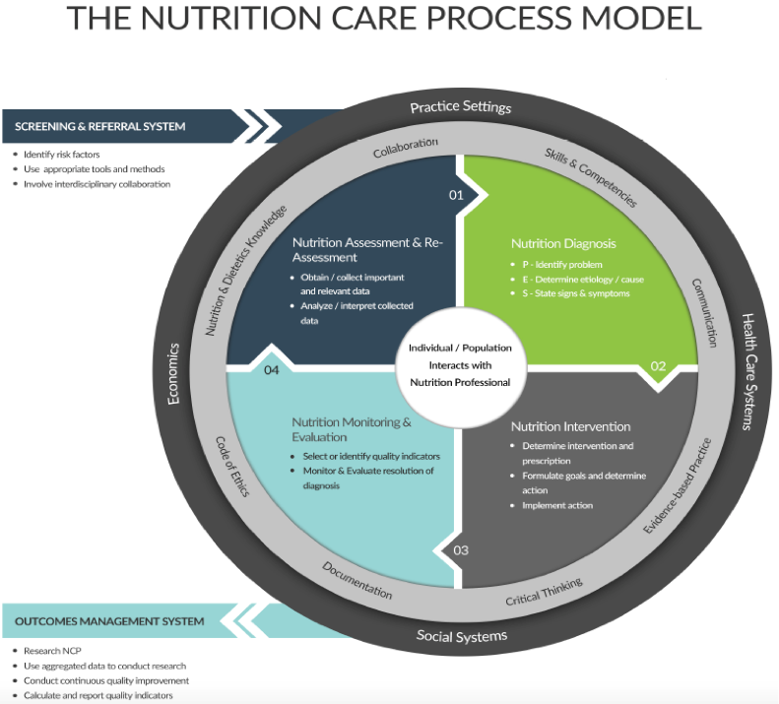2

Step 2: The nutrition diagnosis or nutrition problem is summarized into a structured sentence called a PES statement. (1)
- PES Statements have 3 parts
  - P: Problem
  - E: Etiology
  - S: Signs and Symptoms
- Format for PES Statements
  - Problem related to Etiology as evidence by signs and symptoms

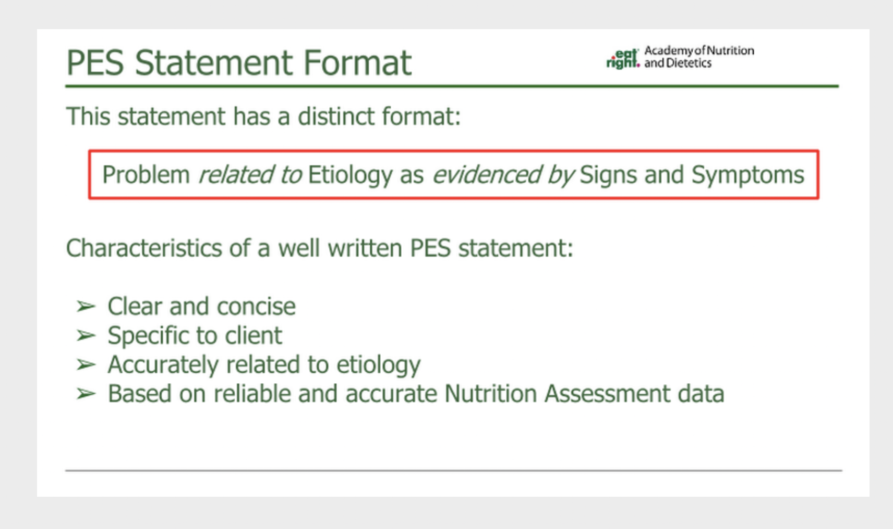
(3)

P: Problem
- Nutrition Diagnosis
  - Most important or urgent nutritional problem identified by the RDN
  - Use data collected during the Nutrition Assessment to identify the nutrition diagnosis
  - Uses specific terminology from the Academy of Nutrition and Dietetics
    - 3 Classifications of Nutrition Diagnosis
      - Intake
      - Clinical
      - Behavioral

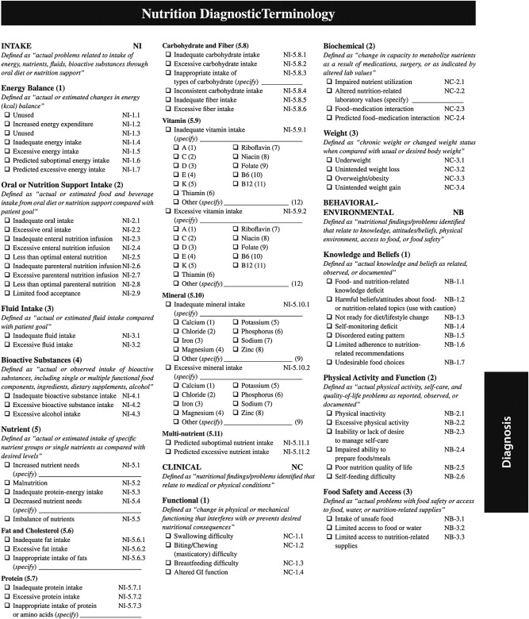(4)
E: Etiology
- Root cause of the problem
- Nutrition interventions should address etiology
S: Signs and Symptoms
- Signs and symptoms that support the problem

After assessing the patient, if they do not meet the criteria for a nutrition diagnosis, it is appropriate to document “ No Nutriiton Diagnosis at this time.”
PES Statement Examples from the Academy of Nutrition and Dietetics (1)
- Excessive Fat Intake related to limited access to healthful options – frequent consumption of high-fat, fast-food meals as evidenced by serum cholesterol level of 230 mg/dL and patient report of 10 meals per week of hamburgers and fries
- Excessive Energy Intake related to unchanged dietary intake and restricted mobility while fracture heals as evidenced by 5 lb weight gain during last 3 weeks due to patient report of consumption of 500 kcal/day more than estimated needs
- Swallowing Difficulty related to post stroke complications as evidenced by results of swallowing tests and reports of choking during mealtimes
PES Statement Examples from S & S RDs
- Severe malnutrition r/t chronic illness (dementia and cancer) as evidence by po intake meets less than 75% of estimated energy requirements for a month or longer, weight loss over 5% in less than one month, and fat loss noted in orbital area
- Obesity r/t suspect years of sedentary lifestyle combined with hypercaloric intake AEB BMI 67.1
- Undesirable food choices r/t non-compliance with therapeutic diet AEB A1c 11% and BMI of 28 indicating he is slightly overweight.
- Inadequate oral intake r/t poor appetite AEB hx of poor PO intake, self-reporting of 3-6 16 oz beers/day, and low BMI
- Altered nutrition related laboratory values related to CKD as evidenced by elevated BUN, creat, and K+ values

- https://www.eatrightpro.org/practice/quality-management/nutrition-care-process
- https://www.andeal.org/vault/2440/web/files/EAL/NCP_EAL_201711.pdf
- https://eal.webauthor.com/go/view/presentation.cfm?uuid=5E185C78-3E80-4B66-B741-3DFA9F6D9960#
- https://www.jrnjournal.org/article/S1051-2276(12)00048-9/fulltext

