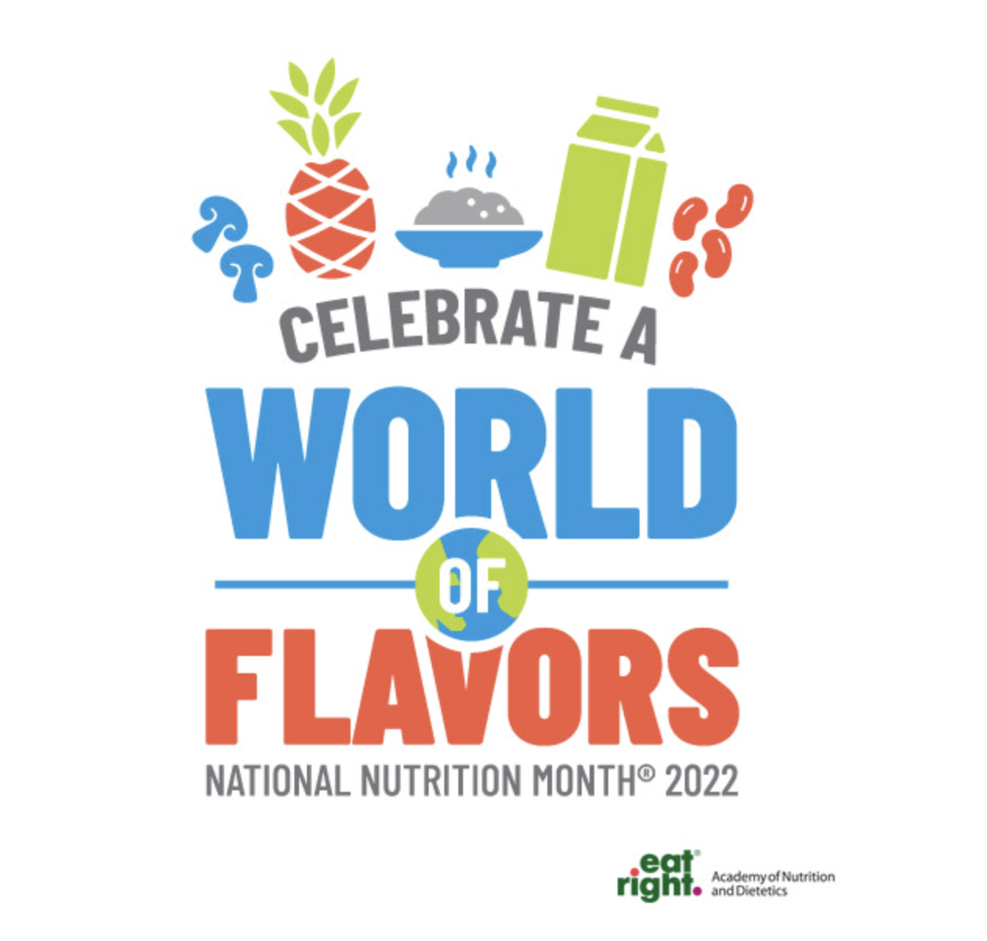

Academy of Nutrition and Dietetics National Nutrition Month Toolkit:
- https://www.eatright.org/food/resources/national-nutrition-month/toolkit\
- Includes Tip Sheets/Handouts, Games and Activities, Presentation Materials, Press Releases
How to Involve your Facilities and Residents
- Nutrition question of the day or week with small prizes
- Have a meal celebrating different cultures , offer special menu items from international cuisines
- Decorate dining room for National Nutrition Month
- Involve your activities director

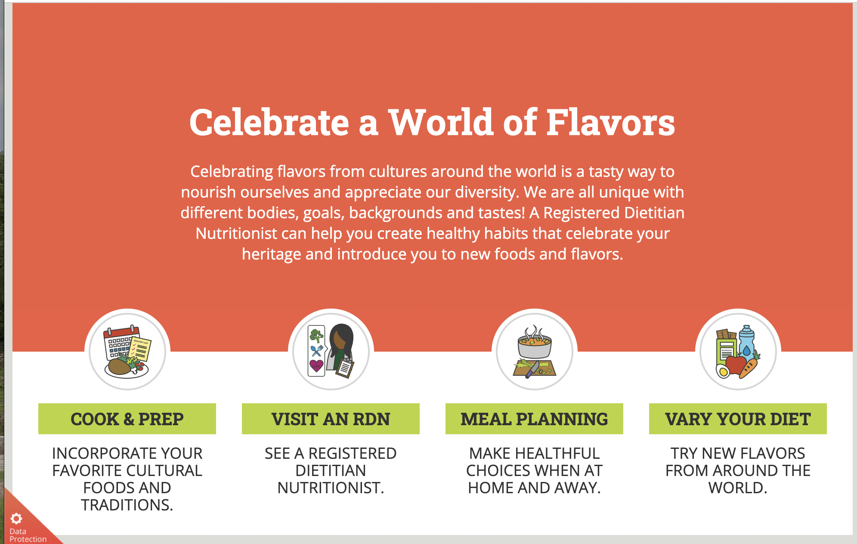
Registered Dietitian Nutritionist Day is March 9, 2022

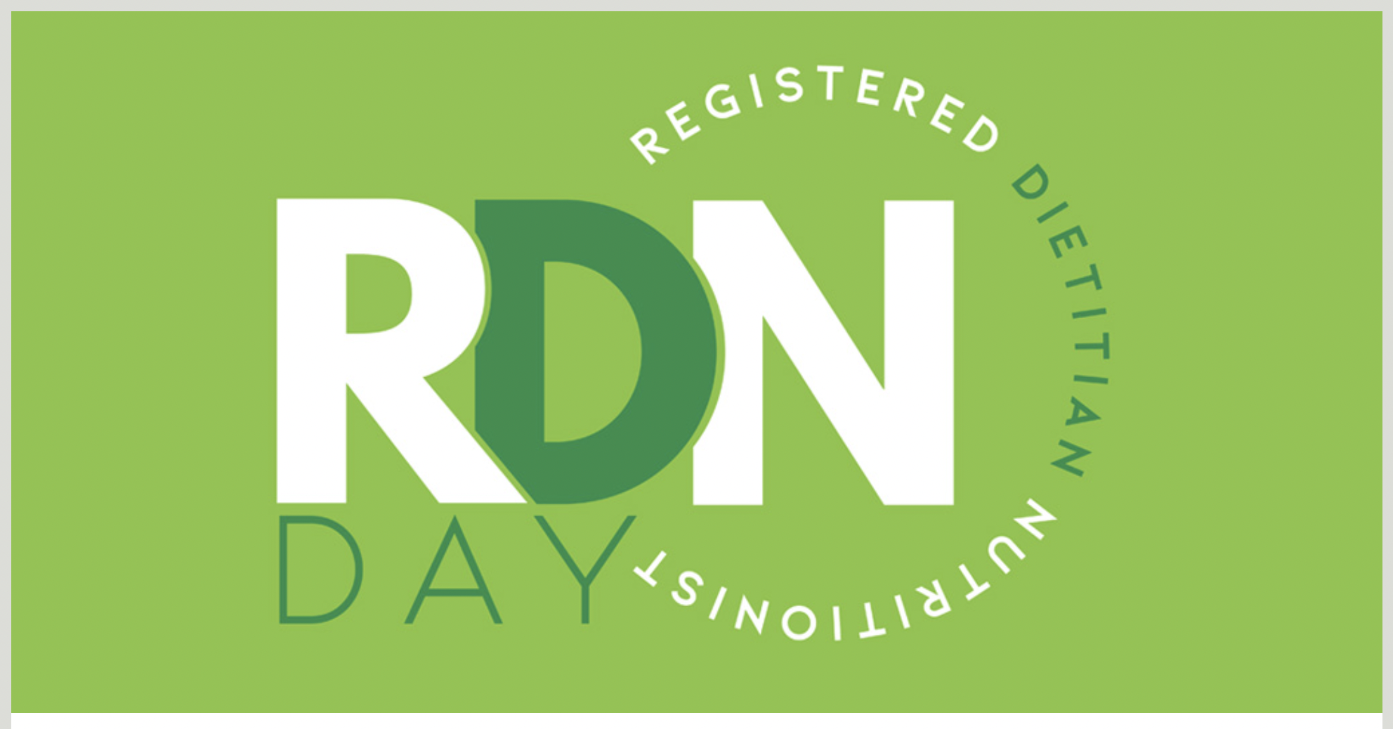

Thank you all for being wonderful RDNs!!! We appreciate all you do for your facilities

