Trivia Questions

- Name a high Vitamin A food
- Broccoli
- Collard greens
- Dark green leafy lettuce
- Kale
- Spinach
- Carrots
- Pumpkin
- Sweet potato
- Apricots
- Mango
- Cantaloupe
- Which survey regulation addresses food preferences?
- F806
- If your resident is on a mechanically altered diet and is having no problems chewing or swallowing, do we still code a swallowing problem on K100 of the MDS?
- No: Per RAI manual: Do not code a swallowing problem when interventions have been successful in treating the problem and therefore the signs/symptoms of the problem did not occur during the 7 day look back period

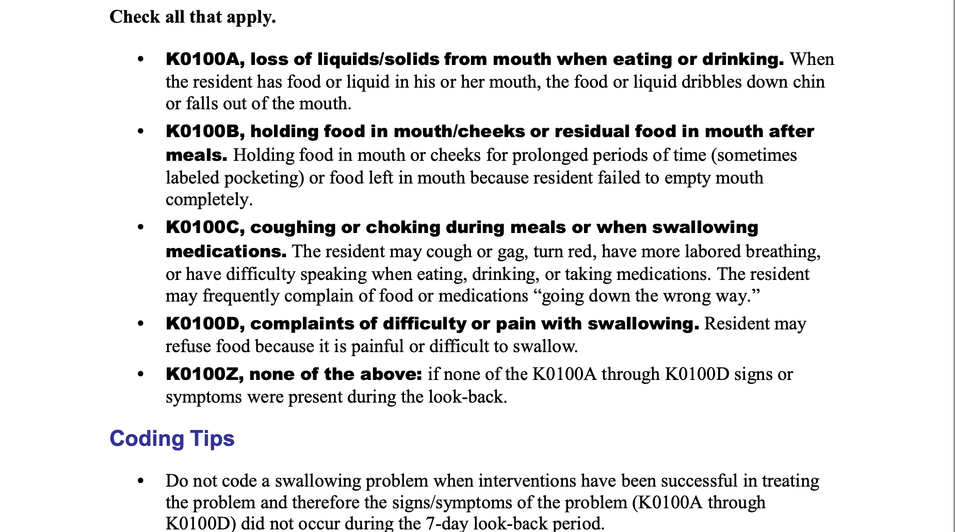
- For IDDSI Level 6, Soft and bite sized, what are the characteristics appropriate testing methods?
- Appearance: No pieces less than 15mm x 15mm, no separate thin liquids
- Fork/Spoon Pressure Test: When pushing down on a 15mm x 15mm sample with a dinner fork or a teaspoon, with enough pressure that the thumb nail turns white, the food can be squashed and will not return to its original shape
- What are the significant weight loss parameters listed on the MDS?
- 5% weight loss in 30 days
- 10% weight loss in 180 days

